**R1**

system/identity/set name=R1

interface/bridge/add name=bridge1 vlan-filtering=yes

interface/bridge/port add bridge=bridge1 interface=ether1 pvid=10

interface/bridge/port add bridge=bridge1 interface=ether2 pvid=10

interface/bridge/port add bridge=bridge1 interface=ether3 pvid=20

interface/bridge/port add bridge=bridge1 interface=ether4 pvid=50

interface/bridge/port add bridge=bridge1 interface=ether7 pvid=50

interface/bridge/port add bridge=bridge1 interface=ether5 pvid=30

interface/bridge/port add bridge=bridge1 interface=ether6 pvid=60

interface/bridge/vlan/add bridge=bridge1 tagged=ether8 untagged=ether1,ether2 vlan-ids=10

interface/bridge/vlan/add bridge=bridge1 tagged=ether8 untagged=ether3 vlan-ids=20

interface/bridge/vlan/add bridge=bridge1 tagged=ether8 untagged=ether4,ether7 vlan-ids=50

interface/bridge/vlan/add bridge=bridge1 tagged=ether8 untagged=ether5 vlan-ids=30

interface/bridge/vlan/add bridge=bridge1 tagged=ether8 untagged=ether6 vlan-ids=60

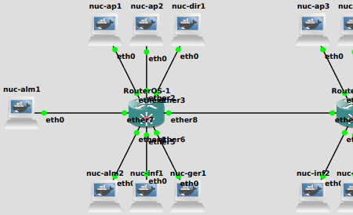

**ETHER8 NOT A BRIDGE**

**R2**

system/identity/set name=R2

interface/bridge/add name=bridge1 vlan-filtering=yes

interface/bridge/port add bridge=bridge1 interface=ether7

interface/bridge/port add bridge=bridge1 interface=ether8

interface/bridge/port add bridge=bridge1 interface=ether1 pvid=10

interface/bridge/port add bridge=bridge1 interface=ether2 pvid=20

interface/bridge/port add bridge=bridge1 interface=ether3 pvid=20

interface/bridge/port add bridge=bridge1 interface=ether4 pvid=30

interface/bridge/port add bridge=bridge1 interface=ether5 pvid=60

interface/bridge/port add bridge=bridge1 interface=ether6 pvid=50

interface/bridge/vlan/ add bridge=bridge1 tagged=ether7,ether8,bridge1 untagged=ether1 vlan-ids=10

interface/bridge/vlan/ add bridge=bridge1 tagged=ether7,ether8,bridge1 untagged=ether2,ether3 vlan-ids=20

interface/bridge/vlan/ add bridge=bridge1 tagged=ether7,ether8,bridge1 untagged=ether4 vlan-ids=30

interface/bridge/vlan/ add bridge=bridge1 tagged=ether7,ether8,bridge1 untagged=ether5 vlan-ids=60

interface/bridge/vlan/ add bridge=bridge1 tagged=ether7,ether8,bridge1 untagged=ether6 vlan-ids=50

interface/vlan/add interface=bridge1 name=b10 vlan-id=10

interface/vlan/add interface=bridge1 name=b20 vlan-id=20

interface/vlan/add interface=bridge1 name=b30 vlan-id=30

interface/vlan/add interface=bridge1 name=b50 vlan-id=50

interface/vlan/add interface=bridge1 name=b60 vlan-id=60

ip address/add address=192.168.1.1/24 interface=b10

ip address/add address=192.168.2.1/24 interface=b20

ip address/add address=192.168.3.1/24 interface=b30

ip address/add address=192.168.5.1/24 interface=b50

ip address/add address=192.168.6.1/24 interface=b60

ip/dhcp-server/setup

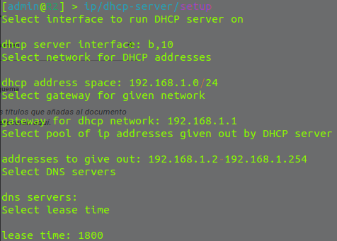

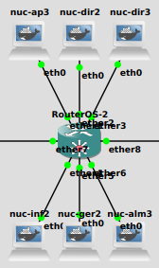

**R3**

system/identity/set name=R3

interface/bridge/add name=bridge1 vlan-filtering=yes

interface/bridge/port add bridge=bridge1 interface=ether1 pvid=10

interface/bridge/port add bridge=bridge1 interface=ether2 pvid=20

interface/bridge/port add bridge=bridge1 interface=ether3 pvid=60

interface/bridge/port add bridge=bridge1 interface=ether4 pvid=30

interface/bridge/port add bridge=bridge1 interface=ether5 pvid=30

interface/bridge/port add bridge=bridge1 interface=ether6 pvid=50

interface/bridge/vlan/add bridge=bridge1 tagged=ether8 untagged=ether1 vlan-ids=10

interface/bridge/vlan/add bridge=bridge1 tagged=ether8 untagged=ether2 vlan-ids=20

interface/bridge/vlan/add bridge=bridge1 tagged=ether8 untagged=ether4,ether5 vlan-ids=30

interface/bridge/vlan/add bridge=bridge1 tagged=ether8 untagged=ether6 vlan-ids=50

interface/bridge/vlan/add bridge=bridge1 tagged=ether8 untagged=ether3 vlan-ids=60

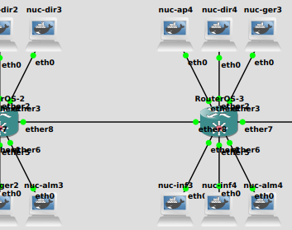

**ETHER8 NOT A BRIDGE**